ALCOHOL EDU ASSIGNMENT

WHAT IS ALCOHOL EDU?
High schools around the nation are combating underage drinking with an online alcohol prevention program designed specifically for today’s youth. AlcoholEdu for High School is an evidence-based, online alcohol prevention program that takes a project-based approach to learning, giving students the opportunity to travel through a community to better understand the risks around drinking alcohol. Developed by leading prevention experts at Outside the Classroom, this course provides an interactive experience that:

- Reduces support for underage drinking
- Improves knowledge of alcohol and its effects
- Motivates behavior change
- Supports safer, healthier decisions regarding alcohol

AlcoholEdu for High School helps students to manage the mixed messages they receive in a culture that too often encourages, rather than discourages, underage drinking.

The course includes:
- Science-based, alcohol-related content
- Interactive exercises
- Pre-Test and Final Exam

The AlcoholEdu for High School Community
As students reach different points in the community (the town hall, a pizza place, a friend's house), they learn different concepts and “unlock” various tools to help them design a billboard containing positive messages they have learned throughout the course. This engaging, interactive format helps students understand how their decisions impact their own lives and their community.
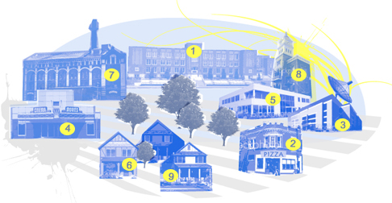

Community Locations and Key Concepts:
- School—Standard drink measurement
- Pizza Place—Myths and facts about alcohol, accurate social norms data
- TV Station—Alcohol expectancies, influences and community issues
- Movie Theater—Blood alcohol concentration
- Research Lab—Brain and body science
- Friend’s House—Peer pressure and decision-making
- Newspaper—Addiction and community impact of alcohol
- Town Hall—Underage drinking laws, policies, and social host liability
- My House—Tips for talking to parents, setting personal goals

ACCESSING ALCOHOL EDU

Go to: http://highschool.alcoholedu.com
Go to New User Log In: Juniors: 12NAJunior
Seniors: 12NASenior
WRITE DOWN EMAIL AND PASSWORD SO YOU REMEMBER

THIS IS WHAT YOU WILL USE TO LOGIN IN THE FUTURE AND YOU WILL LOGIN AS A RETURNING USER

Create an account
- Name
- Birth Date
- Email Address (will become your username)
- Password
- Teacher/Class period
ASSIGNMENT EXPECATIONS

This course will continue from where you have left off today when you login again. You will be expected to travel through each of the community locations to better understand the impact of alcohol on your life and the life of others. At the My House locations you will take your final exam and also create a billboard that promotes a positive prevention message. Both the final exam and billboard are expected to be completed for this assignment.

Things to Remember:
- When you login again, you will login as a returning user using your email the email/password you created
- While going through the course DO NOT use the BACK button
- There is a final exam at the end that you will be expected to pass with a 90%. You can retake it as many times as you need to get a 90%.
- As they mention, it may not be a bad idea to take notes.
- You may want to consider doing this all in one sitting, so you have all the information fresh in your mind. It should take approximately 75 minutes.

Must Complete: Final Exam

Due: Monday, February 25th

Total Points: 30 pts for final exam (when you get 90% or better, you can retake)

Extra Credit: Parent complete Alcohol Edu for Parents (turn in form below when parent completes the course)
10 Points
Go To: http://highschoolparents.alcoholedu.com
LogIn: 12NAParent
**Can not receive extra credit unless you have completed your final exam

ALCOHOL EDU FOR PARENTS SIGN UP SHEET (TURN IN WHEN COMPLETED)

Student Name: __________________________ Phys Ed Pd/Day: _________

Parent Name: ____________________ Parent Signature: __________________

Email Address: ____________________________________________________

