ALCOHOL EDU ASSIGNMENT

Go to: www.everfi.com/login
Click “Sign Up” in the top right corner
Enter the registration code provided by your teacher for each class(see below) and select “I am a Student”
WRITE DOWN USERNAME AND PASSWORD SO YOU REMEMBER

CREATE YOUR ACCOUNT
Date of Birth
First & Last Name
Username (your choice)
Email
Password (your choice)

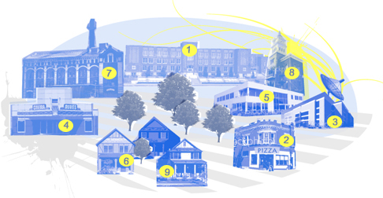
REGISTRATION CODES
2A 42154b0a
2B d80ffa3d
3A 4983107d
3B e5206067
8/9A bab2f1df
8/9B 2d742899
10A 6f908a3a
10B 8f476c85
11A 1162b850
11B 40a22355

EXPECATIONS

You will be expected to travel through each of the community locations to better understand the impact of alcohol on your life and the life of others. At the My House locations you will take your final exam. You will not need to turn anything in, after completing the exam I will be able to see your score. This course will continue from where you have left off when you login again.

Things to Remember:
- When you login again (at same website as above), enter your username and password and click “login”
- While going through the course DO NOT use the BACK button
- There is a final exam at the end that you will be expected to pass with a 70%. You can retake it as many times as you need to get a 70%.
- As they mention, it may not be a bad idea to take notes.
- You may want to consider doing this all in one sitting, so you have all the information fresh in your mind. It should take approximately 75 minutes.

Must Complete: Final Exam with a 70%

Due: Friday, May 23rd

Total Points: 20 points

