North Allegheny Senior High School
Physical Education
Tennis Study Guide

Grip
- Eastern; Most common; Shake hands with the racket with the dominant hand
- “V” formed with thumb and forefinger, running along the straight edge of the racket
- Wrist should be tight, not floppy

Forehand
- Backswing
- Non-dominant shoulder faces the net
- Bring racket back low, with weight on back foot
- Step and Hit
- Transfer weight to front foot
- Contact ball waist height and right at the front foot
- Racket must be flat, straight
- Follow Through
- Racket finishes over the opposite shoulder
- Get into Ready Position

Ready Position
- Feet shoulder width apart with racket out in front of your body
- Knees bent with weight on the balls of your feet
- After you hit a shot and ready to receive a shot you must be in ready position

Backhand
- 2 Hand Backhand
- For beginning players, place non-dominant hand on the racket above the dominant hand (on the neck of the racket)
- Allows for more strength and control
- Dominant shoulder faces the net
- Contact the ball slightly in front of the lead foot
- Hit through the ball and get into ready position
Serve
- Toss
- Non-dominant hand tosses the ball with non-dominant foot facing the post
- Toss to 2 o’clock
- Toss high enough so you can fully extend your arm and racket
- Backswing
- Scratch your back with the racket
- Extend arm and racket fully
- Contact
- Snap your wrist on contact
- Follow Through
- Racket ends to side of non-dominant leg and get into ready position

Rules
- Ball is in bounds if it touches any part of the line
- You can hit the ball out of the air except on a serve
- The tennis ball can only bounce one time before you hit it
- You must serve from behind the baseline and between the sideline and center hash mark
- Must serve to the opposite diagonal service box
- You get two chances to serve it over the net and into the correct service box
- Switch sides of the center hash mark after each point
- Serve for one whole game
- Switch sides of the court every odd numbered game

Object of the Game
- To hit a shot your opponent can not return
- Each time your opponent can not return a shot or returns it out of bounds you get a point
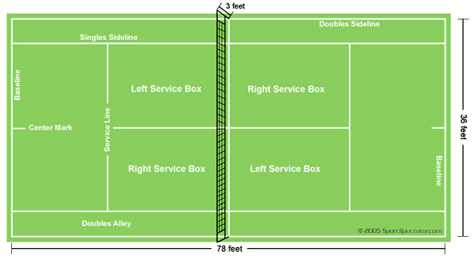
Scoring
- Love = 0
- 15 = 1st point scored
- 30 = 2nd point scored
- 40 – 3rd point scored
- Game = Winner
- Duece = 40-40
- Advantage = Someone is up by one point
- Advantage In = Server wins point after deuce
- Advantage Out = Receiver wins point after deuce
- After Duece you must win by 2 points
- Set = Must win 6 games
Match = Best out of 3 sets (Females); Best out of 5 sets (Males)

Terms
- Rally – Consecutive hits over the net with the ball staying in bounds
- Groundstrokes – Shot made after the ball has bounced (Ex: forehand, backhand)
- Fault – A serve that misses the proper service box
- Double Fault – Losing a point by 2 consecutive serves
- Let – A serve that hits the top of the net before landing in the service box; you get to serve again
- Ace – A serve hit so well that the opponent can not touch it with the racket
- Back court – The area of the court between the service line and the baseline
- Doubles – A contest played with two people on each team
- Singles – A contest between one player on each side of the net
- Smash – Hard over the head shot, most resembles the serve
- Volley – A shot in which the ball is hit out of the air before it bounces
- Topspin – The forward rotation put on the ball by hitting up behind it.
- Lob – A high shot, made defensively to regain court positioning or offensively to clear the reach of the opponent at the net
- Slice – A shot hit with the backspin on the ball
- USTA – United States Tennis Association – the governing body of tennis in the United States

