***Go Math!* Resources:**

***Step 1:*** Log on to **Think Central** using the following web address: [***https://www-k6.thinkcentral.com/***](https://www-k6.thinkcentral.com/)

* **Username: na + lunch number (no spaces)**
* **Password: lunch number**

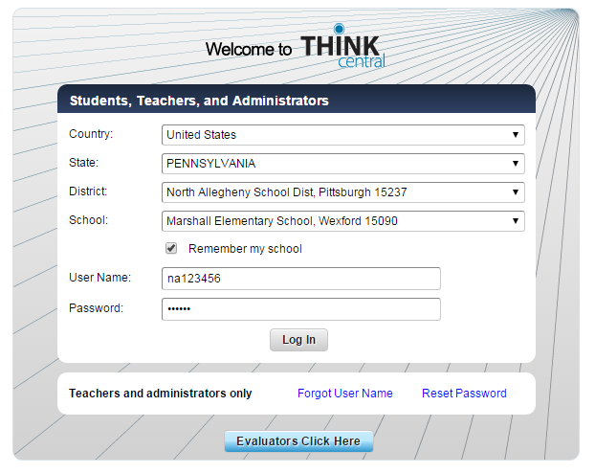

***Step 2:*** Click on **“My Library”**

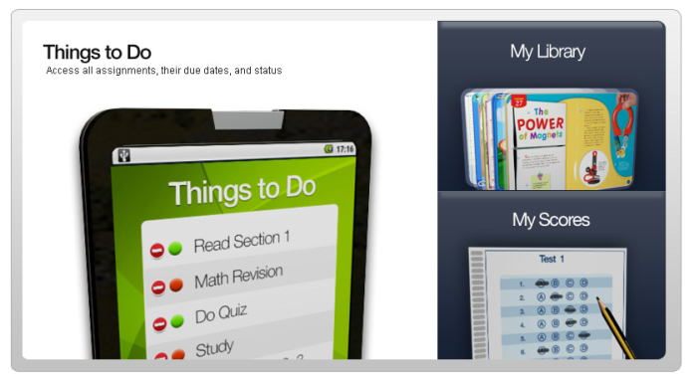

***Step 3: Browse the Resources***

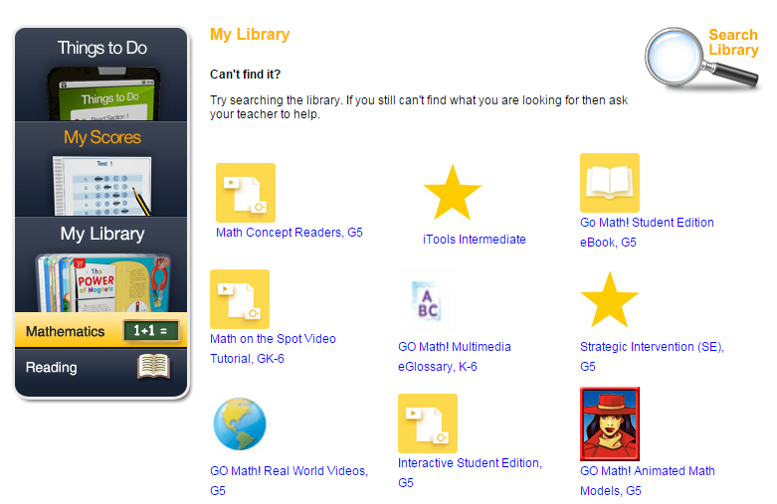

***Go Math!* Resources:**

**Here are some resources that can be used at home and a brief description of how they can best be utilized:**

|  |  |
| --- | --- |
|  | **Interactive, tiered practice for students that includes four main sections:**   * *Learn the Math*   + A quick “how to” for each skill and concept * *Do the Math*   + Guided practice WITH support * *Independent Practice*   + Practice WITHOUT support * *Quiz*   + Formative assessment to check progress and understanding   + Will NOT be graded when used for independent practice |
|  | **This link contains an online version of the student textbook.** |
|  | **The link contains videos for each lesson. This is a great resource for students to use while they are completing their homework or reviewing for an assessment. It is also a great resource for parents working with their children!** |
|  | **Interactive manipulatives such as:**   * Counters, Base-Ten Blocks, Number Lines, Number Charts, Graphs   **And models to help with:**   * Fractions, Geometry, Measurement, Algebra, and Probability   **These tools are great for visual and tactile learners!** |
|  | **This link contains an interactive version of each lesson found in the student textbook. This is a great resource to use to preview a lesson before class or to review a lesson that has already been covered in class.** |
|  | **A great resource to review the vocabulary from the entire K-6 *Go Math!* series.** |
|  | **A great resource for any student struggling with a particular skill or concept. Each practice worksheet includes guided and independent practice opportunities.** |