Name _____________________________________ Date _________________________

**Go Math Chapter 8 Review**

***Complete the problems. Write your answer in simplest form.***

1.

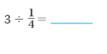

2.

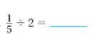

3.

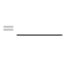

4.

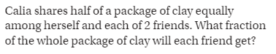

_____________________________________________________________________________________

5.

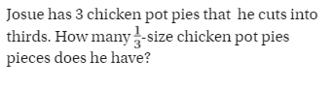

_____________________________________________________________________________________

6.

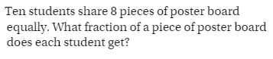

_____________________________________________________________________________________

7.

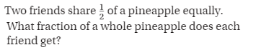

_____________________________________________________________________________________

8.



