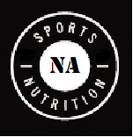

**Sports nutrition**

**2013-2014 Instructor: Mrs. LaSitis**

[**RLaSitis@northallegheny.org**](mailto:RLaSitis@northallegheny.org)

**“Sports nutrition is a part of our players’ equipment. The information in *Sports Nutrition for Coaches* can help your athletes reach their goals. What they eat and drink as well as timing and quantity can translate to optimal performance, improved health, and career longevity.**

**-Mike Tomlin, Head Coach, Pittsburgh Steelers**

**Essential Concepts:**

1-Energy Systems Used for Exercise:

2-Fuel Sources for Sport

3-Timing of Eating for Optimal Performance

4-Hydration

5-Healthy Weight Loss

6- Increasing Muscle Mass

7-Sizing Up Supplements

8-Preventing Common Complaints

9-Coping With Special Diets

10--Eating Disorders/Nutritional Defiencies

11-Drug and Alcohol Use and the Effects on Performance

12- Eating healthy on a budget

13- Logistics and Implementation

13-Implementation for Nutrition in sports

14-Careers in Sports Nutrition and Interviews

15-Final Project: Life as a Coach

**Scoreboard:**

100-90% - A

89-80%- B

79-70% - C

69-60%- D

Grades will be comprised of participation, in-class activities, quizzes, labs, and the final project. The final semester grade will be determined by the final percentage of all grades entered during the entire semester.

**Injured List:** If an activity is missed due to illness or injury, it is your responsibility to see me in order to complete a make-up assignment. If no make up work is submitted, a “0” will be given.

**Repeat Second Down:** If a cooking lab is missed, you will be required to perform the activity at home. You will be given one week to complete this.

**Delay of Game:** Late work will always be accepted for half credit. If nothing is turned in, a zero will be given.If you arrive to class without proper documentation, you will fill out a late card. Three tardies will result in a detention.

**Holding:** You will be responsible for a portfolio from the class. This will be part of your participation grade as well as a way for you to track your growth, measure your success, and will serve as a resource for your final project.

**Challenge Flags:** If at any point you feel your grade is scored incorrectly, please feel free to speak with me before or after class.

**Rules of Play:**

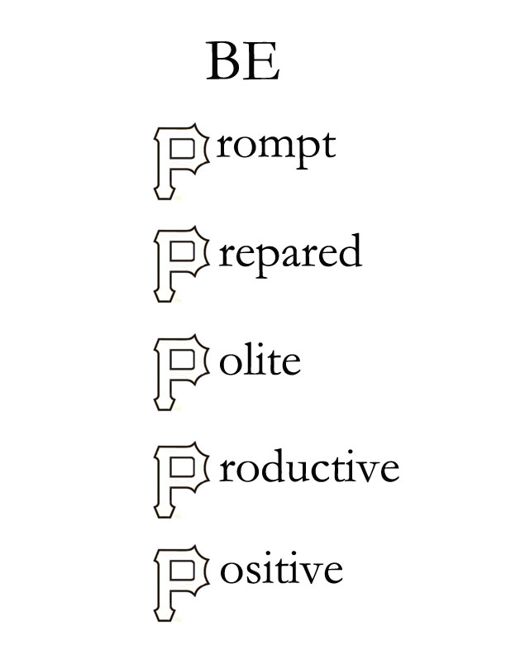

**Penalties:** Failure to do so will be loss of points, loss of play, parental phone call and be considered poor sportsmanship within the league.

**Double Dribble:** All students are expected to clean up after themselves, at all times.

**Uniforms:** For safety and sanitation, please wear a clean wardrobe and long hair must be tied back. If Troy Polamalu can do it, so can you.

**Illegal procedures:**

**Quiet At The Start:** If I am speaking, students should be listening. You will not want to be doing something incorrectly as I may be giving you vital information saving you time and energy. Pay attention and don’t false start.

**Off-sides:** At no point should students be into any of the belongings by the Family Consumer Science staff, including but not limited to, cabinets, closets, and food storage devices without the expressed written or verbal consent of the league commissioner (me.) This will be considered out of bounds, and you will suffer a loss of play.

**Let’s Play Ball!**

Show your athleticism by ripping here:

**-------------------------------------------------------------------------------------------------------------------------------**

**Receipt of Syllabus:**

I have received this syllabus for Sports Nutrition and fully understand that I am responsible for my actions within and outside of the classroom.

Name: (Printed) ______________________________________

Name (Signed) _______________________________________

Date: ______________________________________________

This semester will be a _______________________________ for me!

(enter your favorite sports cliché)

(Examples: Home run! Touchdown! Personal Record (PR)! Gold medal! Slam Dunk!