Name _____________________________________ Date _________________________

**Go Math Chapter 7 Review**

***Complete the problems. Draw a model or show your work. Write your answer in simplest form.***

1.

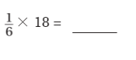

2.



3.

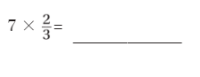

4.

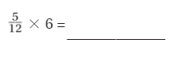

5.

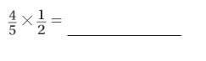

6.

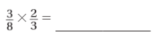

7.

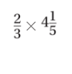

_____________________________________________________________________________________

8.



_____________________________________________________________________________________

9.

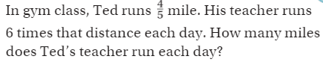

_____________________________________________________________________________________

10.

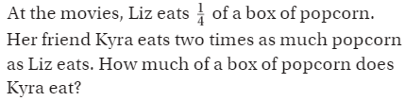

_____________________________________________________________________________________

11.

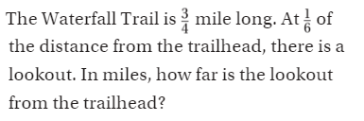

_____________________________________________________________________________________

12.

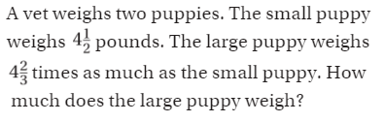

_____________________________________________________________________________________

13.



