Directions for Study Island!

**Study Island- www.studyisland.com**

**Username:** If you forgot your username, please contact me if you can’t find your notecard with the information on it.

**Password:** If you forgot your password, please contact me.

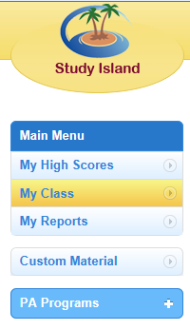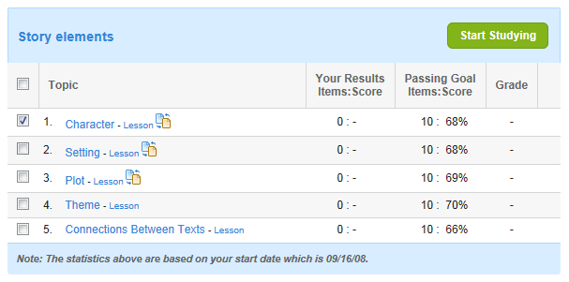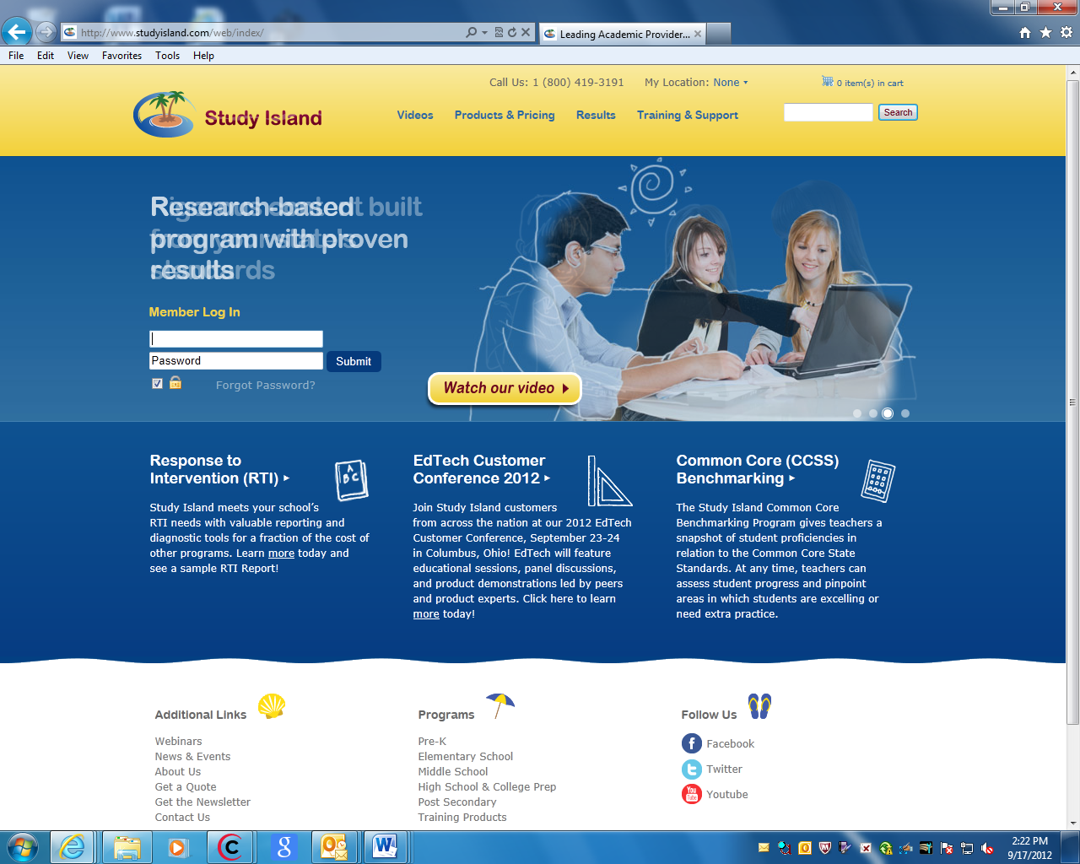

**1. Enter your username and password**

**4. You may select “Practice mode” or “Game mode”.**

**3. Put a check on the assignment and then click on “lesson”. Once you read the lesson, click on “Start Studying”.**

**2. Click on “My Class” & then select “Mrs. Michael”. A drop-down menu of assignments will appear. Click on the assignment you are to complete.**