Study Guide

Reading Mastery Purple Lessons 11-20

Comprehension Skills

* Reading/Rereading
* Story Details
* Perspectives
* Settings
* Sequencing
* Maps
* Vocabulary
* Comprehension
* Writing
* Evidence
* Glossary
* Summarizing

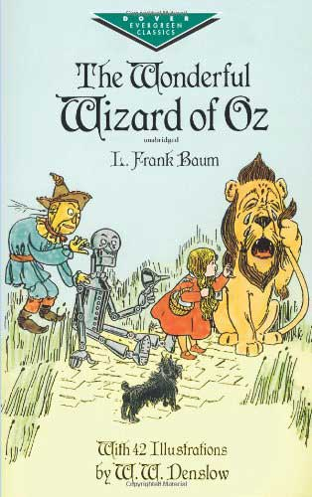

|  |  |  |  |  |
| --- | --- | --- | --- | --- |
| New Vocabulary | | | | |
| Lesson 11 | Lesson 12 | Lesson 13 | Lesson 14 | Lesson 15 |
| 1. people of flesh and blood 2. spoil 3. husky 4. earnestly 5. suspected 6. hearty 7. represent 8. clumsiness 9. fortunate 10. dreary | 1. ray of sunshine 2. maiden 3. satisfaction 4. inconvenient 5. desert 6. companions 7. mystery 8. declared 9. motionless 10. comforted | 1. courage 2. awkward 3. jagged 4. moved 5. shouldered his axe 6. comrade 7. passage 8. misfortune | 1. approve of 2. sorrow 3. unbearable 4. astonished 5. remarkable 6. shiver 7. coward 8. strides | 1. snug 2. crouch 3. gloomy 4. splendid 5. peculiar 6. dreadful |
|  | | | | |
| Lesson 16 | Lesson 17 | Lesson 18 | Lesson 19 | Lesson 20 |
| 1. raft 2. meadow 3. cozy 4. cluster 5. scarlet 6. dazzle 7. scarcely 8. delightful 9. refreshed 10. glare | 1. fond of 2. scent 3. odor 4. mistress 5. shrill 6. timid 7. permit 8. curtsy 9. spicy 10. therefore | 1. stunned 2. drawn 3. dwelled 4. presence 5. glittered 6. throne 7. oats | 1. countless 2. tint 3. guardian 4. marble 5. studded 6. admit 7. basin 8. prefer 9. spectacles | None |

Reading Text

* The Wonderful Wizard of Oz (Chapters 6 to Chapters 15)

Spelling Words

1. different
2. straightness
3. wrongful
4. carefully
5. selfish
6. study
7. signal
8. stretching
9. wreckage
10. usage