Foods Americana – Mrs. Lasitis 2013-2014 syllabus

Congratulations

* on your decision to take the most delicious class at NASH!
* on your choice to hone your culinary skills (a good cook never lacks friends)!
* on your opportunity to learn the fine art of all-day, slow cooking in the kitchen, the need for quick dishes available on the fly, and the importance of fresh ingredients. You will learn all of these!

Course description:

This foods course is designed for students to learn about the historical and cultural influences that have contributed to regional food specialties in our country. It will provide students with the opportunity to experience the application of basic food principles of food science and the relationship to individual, family, and societal wellness. While identifying factors that influence food customs, students will prepare and evaluate the nutritional content of regional foods. Various forms of technology will be experienced in meal preparation and in the discovery of career options.

Topics covered:

* Safety and sanitation procedures in the kitchen
* Measurement techniques and equivalents
* Recipe properties
* Understanding and caring for kitchen equipment
* Operating kitchen appliances
* Demonstrations of cooking techniques, cooking shows
* Recipe files
* Discovery of regional foods specific to orientation

Keys to success:

* Effort and attitude: a helpful and willingness to learn.
* Attendance! Nothing can replace experience, and you will learn while you’re here!
* Appreciation and flexibility: Seasonality, store sales/availability may alter plans
* Check the absent folder if you were not here.
* Feedback to me; I appreciate your likes/dislikes, suggestions for improvement

Classroom Policies:

* Please leave bookbags in the hallway (on stackable shelving)to lessen classroom congestion.
* Arrive on time, or fill out “Late for LaSitis” slip.

Grading:

* Grading will be based on an accumulation of quizzes, classroom participation, clean up and sanitation, and kitchen skills.
* The grading scale will be 90-80-70-60.

Please shade in all the states you have visited in your short lifetime:

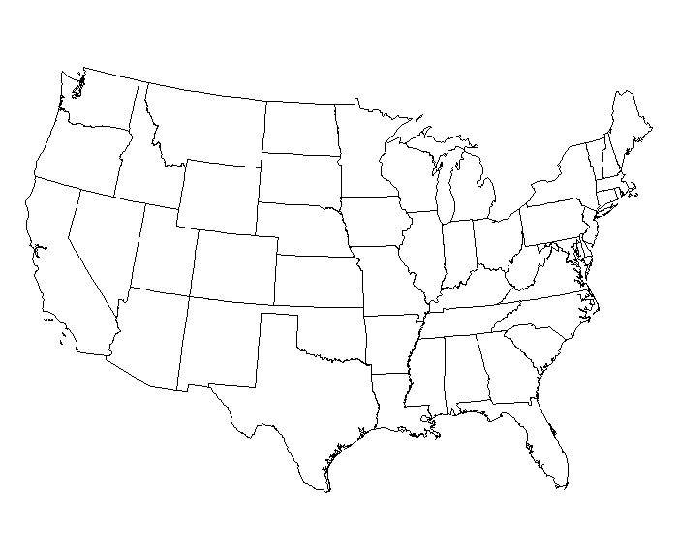

What is your favorite restaurant?

What city is it in?

What is the best thing you’ve ever eaten?