Study Guide

Reading Mastery Purple Lessons 41-50

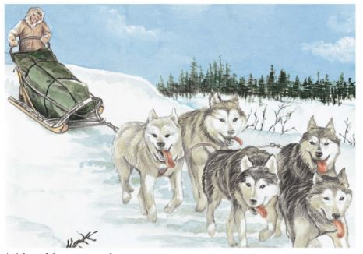

Spelling Words

1. stranger
2. govern
3. movement
4. preserve
5. mistaken
6. spotless
7. undrinkable
8. groaning
9. thoughtful
10. stretcher

Reading Text

* The Domestication of Animals
* The Cat Who Walked Himself
* Journey to Dawson
* Buck

Comprehension Skills

* Fact/Fantasy
* Story Details
* Perspectives
* Settings
* Sequencing
* Character Traits
* Vocabulary
* Comprehension
* Writing
* Research
* Neither/Nor Sentences
* Maps
* Classification

|  |  |  |  |  |
| --- | --- | --- | --- | --- |
| New Vocabulary | | | | |
| Lesson 41 | Lesson 42 | Lesson 43 | Lesson 44 | Lesson 45 |
| 1. advantages 2. prey 3. generation 4. keen | None | 1. gnaw 2. bargain 3. shall 4. pounce 5. accept | 1. eventually 2. scrambled 3. disgraceful 4. lean 5. vivid 6. descended 7. treacherous | 1. rustling 2. slosh 3. miserable 4. crest |
|  | | | | |
| Lesson 46 | Lesson 47 | Lesson 48 | Lesson 49 | Lesson 50 |
| 1. murmur 2. whittling 3. sneer 4. coil 5. exchanged 6. flickered 7. hurl 8. limp | 1. lingered on 2. buds 3. staggered 4. sap 5. runners | 1. recover 2. embrace 3. ideal 4. affection 5. haunt 6. tolerated 7. naked 8. grapple | 1. strangle 2. flushed 3. guilty 4. jutted out 5. reared up 6. stretch 7. clutched | 1. witness 2. lunge 3. quiver 4. grate |