In an ecosystem, birds depend on insects to survive. If someone spreads pesticide to control the insect population, which of the following is most likely to happen? | The bird population will decrease.
Why do trees like the maple and spruce grow in a temperate rainforest community? | The trees grow well in a dry, cool climate.
Which biome is home to more species than any other biome? | Tropical rainforest  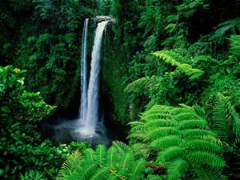
Which adaptation BEST helps elk survive in the taiga biome? | Thick fur
Which of the following is the source of MUCH of the oxygen in the atmosphere? | Plankton in the oceans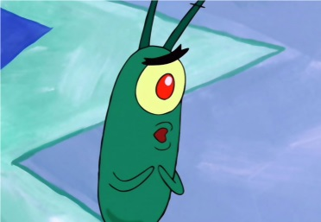
A plant in the desert would most likely have which root system? | A large root system close to the surface
Creatures that live in the deep ocean need to adapt to which environmental factor? | High pressure
Both orbvgganisms need each other to survive in which of the following examples? | A fungus and a bacteria forming a lichen
Different kinds of plants living in the same area must compete for water. Which kind of plant has the greatest chance of survival? | The plant with the largest root system
Look at the energy pyramid below. Where is the greatest amount of energy?  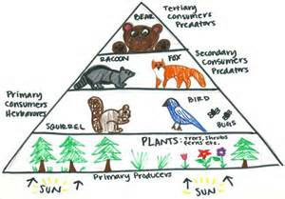  D  C  B  A | D
How do carnivores obtain energy? | They eat animals
What role do decomposers play in an ecosystem? | They break down waste and dead matter.
When decomposers break down the remains of dead organisms, what do they make that can be used by plants? | Nitrogen compounds
Label each organism as a producer or consumer.  Next, label each consumer as an herbivore or carnivore.  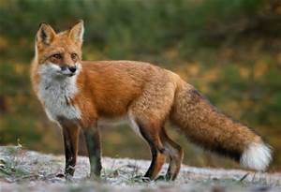  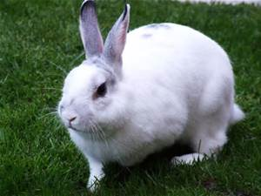  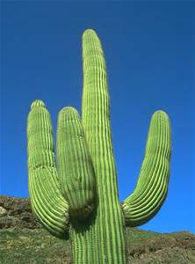 | Consumer  Carnivore  Consumer  herbivore  producer

