Study Guide

Reading Mastery Purple Lessons 31-40

Comprehension Skills

* Reading/Rereading
* Story Details
* Perspectives
* Settings
* Sequencing
* Character Traits
* Vocabulary
* Comprehension
* Writing
* Evidence
* Descriptions
* Maps

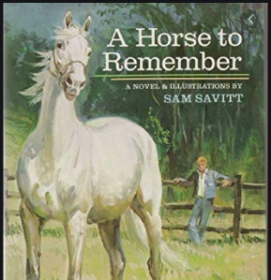

|  |  |  |  |  |
| --- | --- | --- | --- | --- |
| New Vocabulary | | | | |
| Lesson 31 | Lesson 32 | Lesson 33 | Lesson 34 | Lesson 35 |
| None | 1. reeds 2. ease 3. echo 4. bruise | 1. reflection 2. moss | 1. alert 2. nag 3. pasture 4. develops 5. plod 6. thoroughbred 7. nudge | 1. resist the impulse 2. barrier and obstacle 3. cock your head 4. blurt out 5. stall 6. stray 7. exhausted 8. endurance |
|  | | | | |
| Lesson 36 | Lesson 37 | Lesson 38 | Lesson 39 | Lesson 40 |
| 1. brace yourself 2. abruptly 3. gallop 4. dilapidated 5. marvel 6. spectators 7. mock | 1. mount a horse 2. officials 3. shabby 4. numb | 1. push a horse too hard 2. let a horse out 3. hold a horse in caution 4. magnificent 5. turf 6. pound | 1. lagging behind 2. prance 3. dangling 4. straining 5. frantically | 1. domestic animals 2. relatives |

Reading Text

* The Ugly Duckling; A Horse to Remember (Chapters 1-7)

Spelling Words

1. children
2. maddest
3. notable
4. frightful
5. defining
6. valuable
7. stylish
8. wrecked
9. strengthen
10. different