Name _____________________________________ Date _________________________

**Go Math Chapter 6 Review**

***Complete the problems. Write your answer in simplest form.***

1.

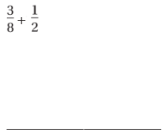

2.

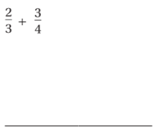

3.





4.





5.

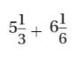



6.





7.

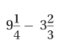



8.

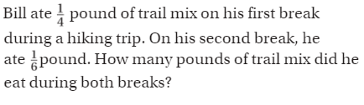

_____________________________________________________________________________________

9.

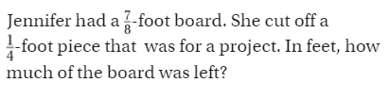

_____________________________________________________________________________________

10.

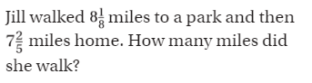

_____________________________________________________________________________________

11.

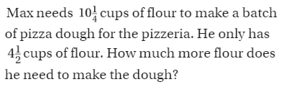

_____________________________________________________________________________________

12.

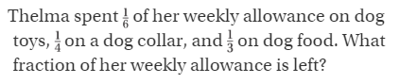

_____________________________________________________________________________________

13.



